Sample Activity 1: Bridges
Synopsis
Each student builds the lightest-weight bridge he or she can that spans a 24-inch space between two supports. The bridge must be made from simple materials and must be able to support a standard brick (about five pounds). In the process, students formulate the basic engineering principles of bridge design.

Objectives
This exercise provides students with an opportunity to use model-building as a way to help understand the forces and phenomena at work in the world around them. This process skill is a component of the Science as Inquiry strand of the NC Standard Course of Study for Middle School Science: "Mastery of integrated process skills: formulating models." Likewise, this exercise meets the NSES Content Standard A (Science as Inquiry) for levels 5-8, "Abilities Necessary to do Scientific Inquiry: develop descriptions, explanations, predictions, and models using evidence."

Through follow-up discussions, specific curricular objectives can be addressed. Depending on the direction of these discussions, students can be expected to be able to do any of the following:
- describe gravity as a universal force that pulls everything toward the center of the earth;
- distinguish between tensile (stretching) and compressive (squashing) forces;
- analyze the relationships between form and function in man-made structures; and
- describe science and technology as human endeavors, influenced by the prevailing cultures and beliefs of the time.

Procedure
The exercise: Ask students to design and build a bridge that sits on two flat supports and spans the 24-inch space between them. The bridge must be able to support a standard brick (about 5 pounds). They may use any material derived from plant fiber (cellulose): paper, cardboard, wood, string, thread, cotton fabric or cotton in any form. Plastic is not allowed—no monofilament fishing line or plastic straws. Metal is not allowed—no coat hangers or steel rods. The bridge may not be attached to any other support. No glue or sticky tape is allowed, even within the bridge structure itself. The above description includes many constraints that can be changed or eliminated according to taste. For example, the use of glue certainly makes this challenge more accessible to younger students. Plastic straws are cheap and easy to obtain in quantity. Teachers should feel free to modify these instructions as much or as little as they wish.

The test: A convenient test set-up is two concrete building blocks standing on their ends. This allows the bridge to sag or have other below-the-support structure. The blocks should be placed exactly 2 feet apart. Each student should place the brick on her own bridge.

Of those bridges that successfully span the 24 inches and support the brick, the one that weighs the least wins the gold star.

Discussion and Extensions

As they test their bridges by placing a brick upon them, students will notice how the bridge deflects downward under the weight of the brick, probably causing some elements of the bridge to bend. A bent object is subjected to two types of forces at the same time: the material on the outside of the bend is being stretched, and the material on the inside of the bend is being compressed. It is easy to illustrate this with a large sponge on which grid lines have been drawn with a permanent marker, as shown in the illustration below.

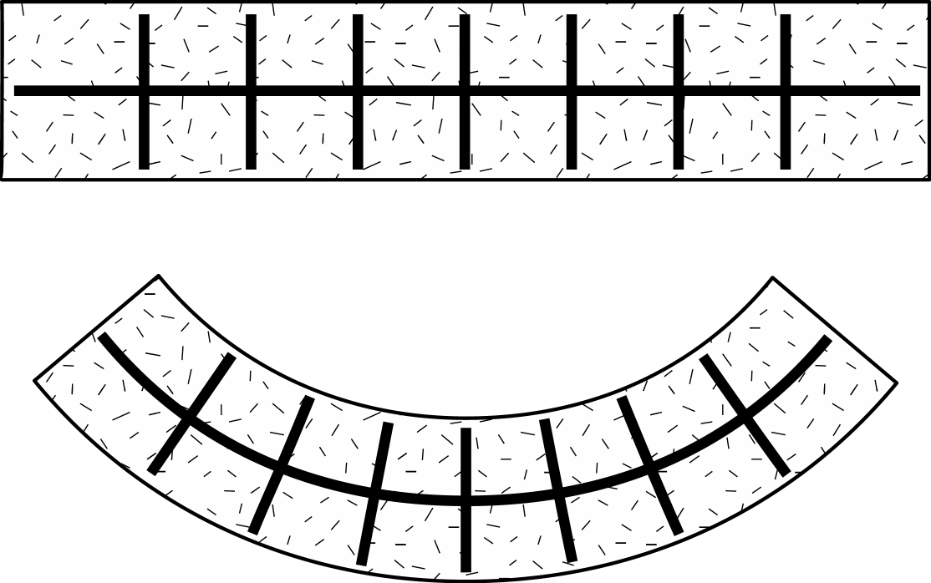

Figure 1. In the unbent sponge at the top, the grid lines are spaced equally along the top and bottom edges of the sponge. In the bent sponge, below, the grid lines are closer together along the top edge and farther apart along the bottom edge.

Some materials and shapes are better equipped to handle the stretching, or tension, that occurs during bending, and some are better equipped to handle the compression. For example, thin rods are very light in weight and can handle tension just fine. String, rope, and wire are extreme examples of long, thin rods; they are used quite successfully in suspension bridges. Long, thin rods, however, do not work well in compression. If you push on the two ends of such a rod, it bends and then kinks if it is made of metal, or it bends, kinks, and breaks if it is made of wood or plastic. Wire, rope and string, of course, are absolutely useless for resisting compression.

Stone and concrete, however, work very well in compression; it's pretty hard to crush them. Most of the world's oldest bridges that are still standing are made of stones arranged in great arches. By arranging the stones in an arch shape, the bridge is always under compression due to the weight of the stones themselves. Stone and concrete can, however, be pulled apart, so they are less than ideal for handling tension. Nowadays when structural engineers use concrete in bridges (or buildings), they generally embed some sort of mesh or grid of metal rods or wires within the concrete to give it more tensile strength.

Wood works reasonably well in both tension and compression. Trees sometimes have to withstand strong winds and so are subject to bending, yet they seldom break along their trunks. In very strong winds, trees generally get uprooted before they snap. The problem with wood is that it is very biodegradable, so wooden bridges tend to be comparatively short-lived.

After students have had an opportunity to experiment with their own bridges, you can then present examples of modern bridges on down through antiquity. (Don't forget suspension bridges made of natural materials by aboriginal peoples all over the world.) You can ask students to research different types of bridges, and compare their relative advantages and disadvantages. A good place for students to get started is the website http://www.pbs.org/wgbh/nova/bridge/build.html. Although it is meant to complement the 1997 Nova television program Super Bridge, which chronicles the design and construction of a 4,260-foot bridge across the Mississippi River in Alton, Illinois, the website can stand alone as an excellent resource for students. It is not necessary to watch the program to appreciate the information and interactive program contained in the website.

Middle school students love disaster stories, and there have been some notable bridge failures in recent history, especially the Tacoma Narrows suspension bridge. In fact, most of what is now known about bridge building is the result of bridges that collapsed -- not unlike the way the students just figured out for themselves how to make a successful bridge. The Nova website mentioned above includes film clips of the Tacoma Narrows bridge as its span oscillates and then crashes into Puget Sound below. Some very readable information about the bridge design and its failure can be found in Henry Petroski's book, Engineers of Dreams.

Virtually every major city in the world is built on the banks of a river, and why this is so would be a good subject for class discussion. While there were certainly historical advantages for being on a river, most modern cities now face major traffic problems because of that very fact. Moving hundreds of thousands of people across a river each day as they commute to and from work is a major headache for traffic planners! When students quite reasonably ask, "Why don't they just build more bridges?", you can challenge them to find out how much it costs to build one.

There are many inspiring books on bridges from around the world that give insights into the cultures and societies that built them. See, for example, the stunning photography in Bridges by Graeme and David Outerbridge (1989, Harry N. Abrams). Also, the book Structures—or Why Things Don't Fall Down, by J.E. Gordon (1978, Plenum) is a delightful paperback that we highly recommend as background reading for this and other exercises about structures.
Instructions for Students

The exercise: Design and build a bridge that sits on two flat supports (concrete blocks standing on end) and spans the 24-inch space between them. The bridge must be able to support a standard brick (about 5 pounds). You may use any material derived from plant fiber (cellulose): paper, cardboard, wood, string, thread, cotton fabric or cotton in any form. Plastic is not allowed—no monofilament fishing line or plastic straws. Metal is not allowed—no coat hangers or steel rods. The bridge may not be attached to any other support. No glue or sticky tape is allowed, even within the bridge structure itself.

You have a week to design and construct your bridge. Don’t put off your construction till the last minute. When you test it at home, it may break and then you’ll have to start your construction again. Structural failure is okay; it is unlikely that lives will be lost in this particular case. But leave yourself time to rebuild your bridge with modifications before the due date.

Of those bridges that successfully span the 24 inches and support the brick, the one that weighs the least wins the gold star.

The test: When you come to class, we will have set up two concrete building blocks standing on their ends. The blocks will be placed exactly 24 inches apart. You will set up your bridge yourself, and then you will place the brick yourself. But we will all partake in the thrill of your victory or the agony of your defeat!

Sample Activity 2: Clay Boats

Synopsis

Each student uses a small quantity of modeling clay to make a boat that will float in a tub of water. The object is to build a boat that will hold as much weight as possible without sinking. In the process of designing and testing their boats, students discover some of the basic principles of boat design and gain first-hand experience with concepts such as buoyancy and density.

Objectives

This exercise provides students with another opportunity to use model-building as a way to help understand the forces and phenomena at work in the world around them. Both successful and unsuccessful models allow students to make inferences, refine hypotheses, and draw conclusions about the behavior of materials and structures. All of these are important aspects of the type of inquiry we call science. As such, this exercise addresses the Science as Inquiry strand of the NC Standard Course of Study for Middle School Science: "Mastery of integrated process skills: formulating models." In addition, after completing this exercise students will be able to describe some of the relationships between form and function in man-made structures, using elements of boat design as examples.

Materials

- One half stick (about 2 ounces) of modeling clay (non-hardening) per student
- One tub of water, at least six inches deep, per four or five students
- 100+ large washers, e.g., 1.5" fender washers (available from hardware stores)
- paper towels

Procedure

Part I: Write on the board, "Create an object out of clay that will float." Give each student a half stick (2 oz.) of clay, and have several tubs of water placed throughout the classroom. Let them know they can test their objects as often as they like. (The paper towels can be used to pat the clay dry before shaping into new designs.) Part I should take no more than 5 minutes.

Part II: As students successfully complete Part I, challenge them with a new goal. Write on the board, "Design an object out of clay that can carry the largest load of washers possible." Show students the washers that will be used to make up the load.

Allow about 15-20 minutes for Part II. As students work, encourage them to continue making improvements every time their boats sink. Students may become competitive and want to declare a winning boat, but it is possible that a tie for the number of washers supported will occur. Should this happen, you could try using a balance to determine the actual mass of the washers held, since there will be slight variations in the masses of individual washers.

Discussion and Extensions

Stimulate a discussion by asking questions referring to experiences the students had while designing their boats. Some examples include:

- What did you notice while building your boats?
- Why did you make the changes you made?
- What boat designs seemed to work best? What is it about these designs that made them successful?
- What boat designs didn't seem to work well? What is it about these designs that made them less successful or unsuccessful?
- How did your boat change throughout the activity?
- How does the process of building a boat relate to the way the scientific process works?

The last question may take some guidance in order for students to formulate an answer. The point is to lead students to realize that:

- each boat design they tested reflected a hypothesis they had about what would help the boat float;
- each test produced data -- either the boat sank or it didn't;
- the data was used to formulate a new hypothesis, which led to yet another test.

This exercise can stop here, or it can go on in two or more different directions. Most likely, students will have a number of observations about the shapes of successful boats, and express some curiosity about "real" boats and their design features. They may also wonder what it is that allows a boat to float in the first place. Thus, the principles of boat design and the principles of density and buoyancy are two obvious directions for extending this exercise. What follows is information about the shapes of boat hulls or the parts of the boat that are underwater, since this is what students were experimenting with in this exercise. The principles of density and buoyancy are left to the exercises Floaters and Sinkers and What Floats Your Boat?

Boat Hulls -- Form and Function

With photographs from books and magazines, students can compare their own designs to boats commonly used for trade and recreation, both past and present. They can be guided through observations about the trade-offs between speed (how fast the boat can go with a given power source), stability (how likely the boat is to tip over under a given sideways force), draft (how deeply the boat rides in the water), and cost (how expensive a given design is to build). As students consider the different types of boats and their features, try to emphasize the relationships between the design, or form, of the boat, and its function.

The more successful of the student-designed clay boats probably resembled a flat-bottomed bowl. This design will hold many washers -- as long as the weight is carefully distributed in the boat. This is a feature of flat-bottomed boats: they require careful balancing of the cargo and passengers, or else they become unstable and prone to tip and take on water. A distinct advantage of flat-bottomed boats is that they have a shallow draft, meaning their hulls do not extend very far down below the surface of the water compared to other hull shapes (see Figure 1). Flat-bottomed boats are thus desirable for moving around in shallow water. Their simple shape also makes them the least expensive type of boat to build. Flat hulls are typically found in small utility boats such as Jon boats, and were commonly used in the last century as barges to transport goods on the quiet waters of canals in this country and in parts of Europe.

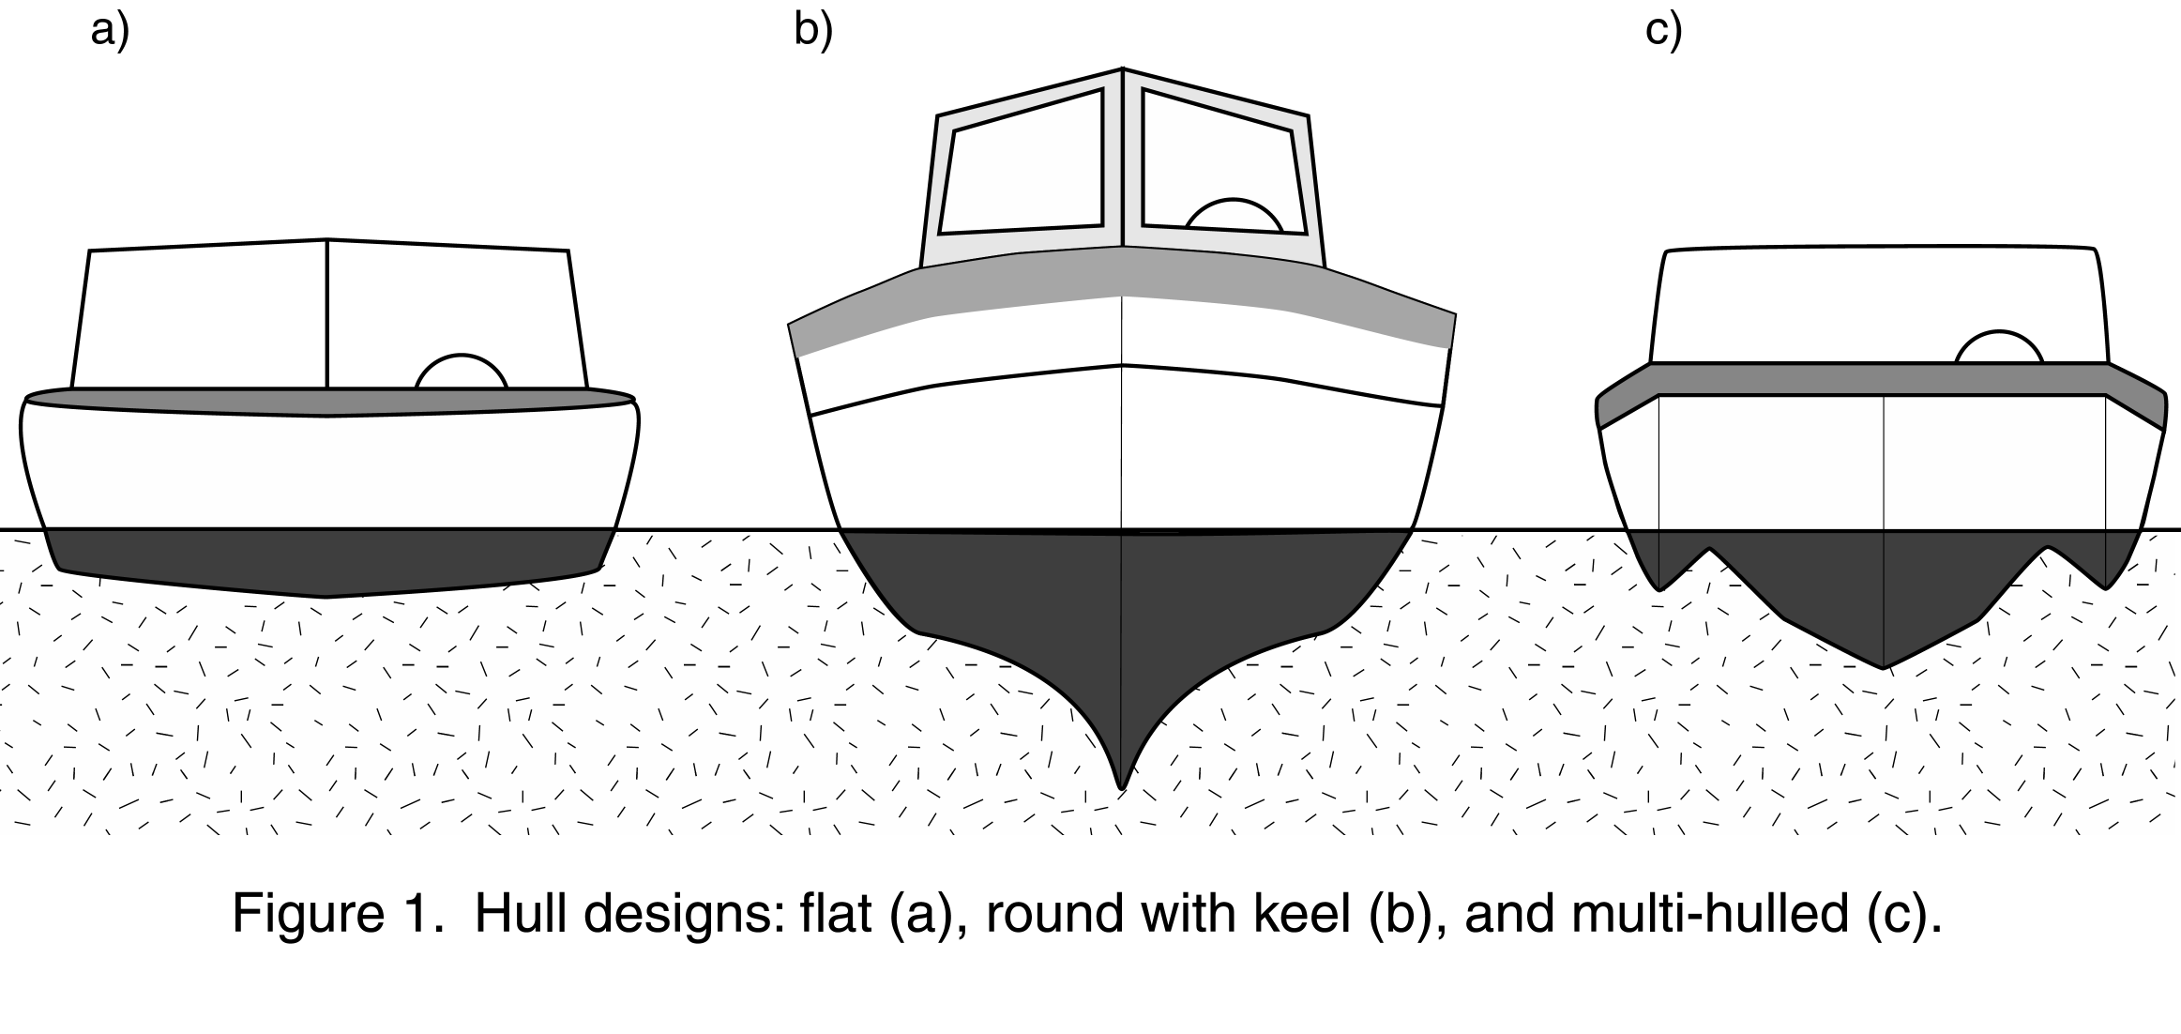
The more contemporary use for flat-bottomed boats is as high-speed runabouts for recreational purposes. In this case the flat hull is designed to rise up and ride on top of the water rather than cutting through the water, thereby encountering the reduced friction of moving through air instead of water (see Figure 2). Although it takes a lot of engine power to get the hull up, at which point the boat is said to plane, it can then travel at very high rates of speed. A disadvantage of flat hulls is that they give a rough ride if any waves are present, because the entire width of the boat's bottom is in contact with the water. (Even when planing, the back, or stern, of the boat is still in the water.)

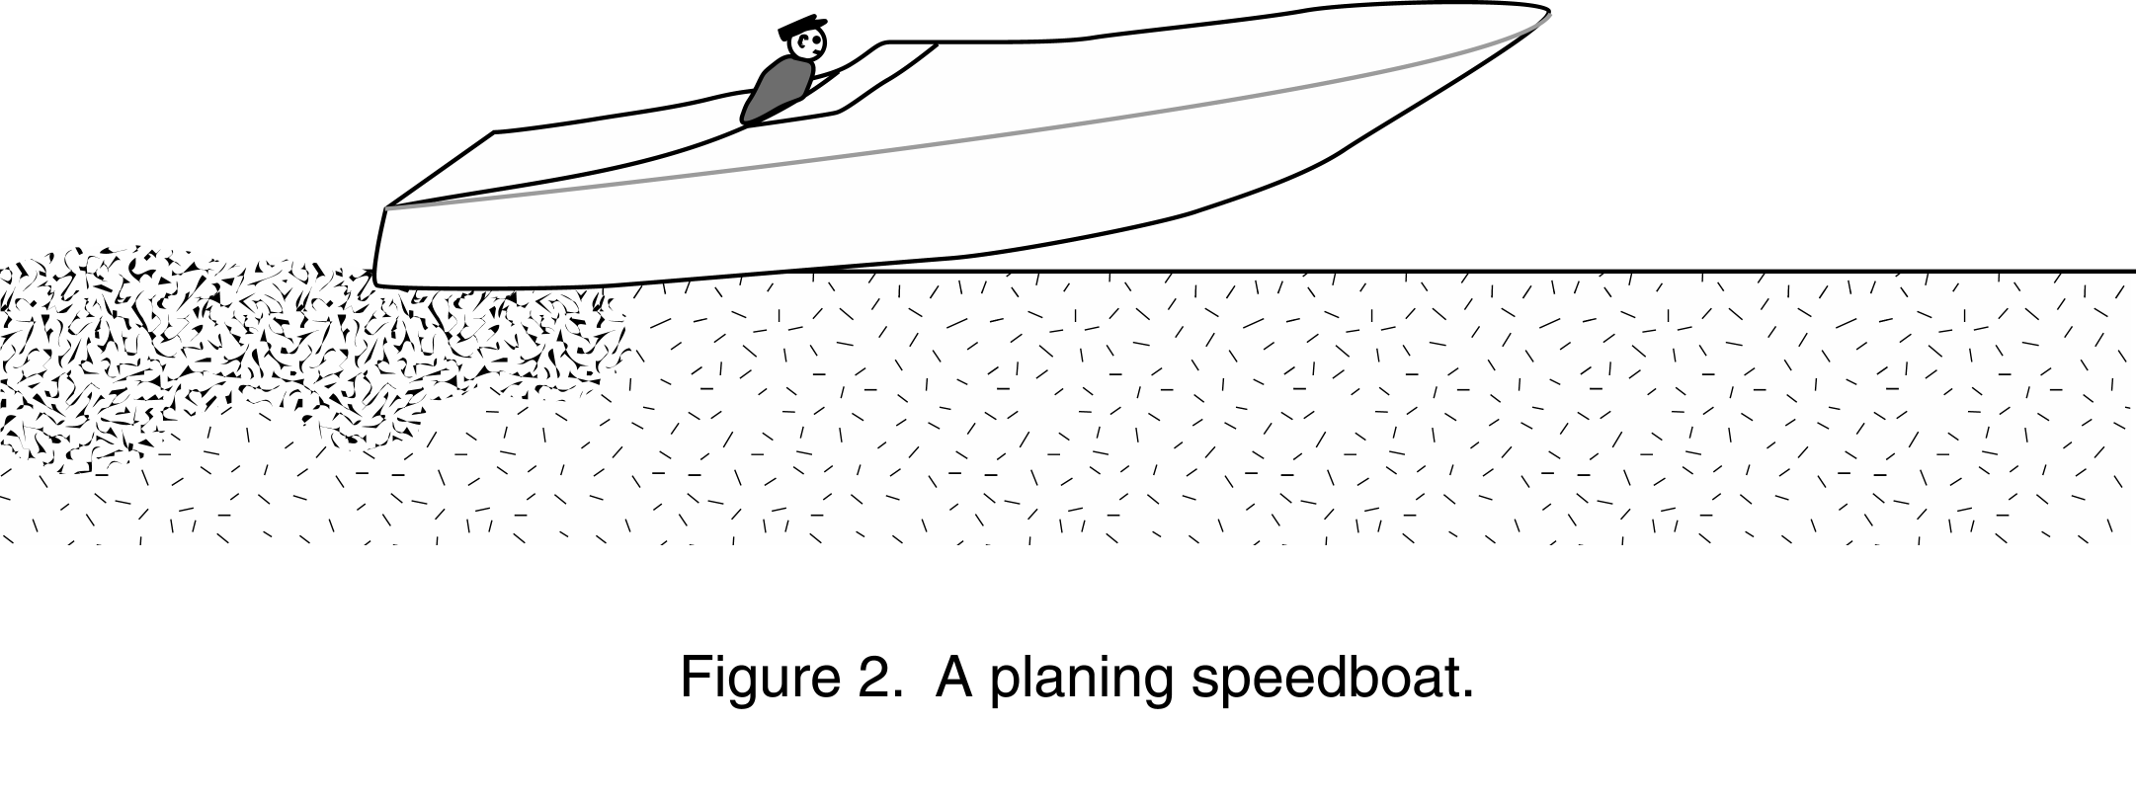
Some students may have tried making boats from their clay that were shaped more like canoes, with tapered ends and rounded hulls. Tapered ends certainly let a boat move through the water more efficiently than a bowl-shape, since water can easily flow around the front (bow) of the boat if it is tapered. The rounded hull, however, presents a problem because such boats roll easily and take on water or capsize. Large sailboats, fishing trawlers, and cargo ships, which do have rounded hulls, generally also have keels. A keel is a narrow V-shaped extension of the hull along the boat's centerline that helps prevent excessive rolling (see Figure 1b). Because the keel extends down into the water, these boats cannot travel in shallow water the way boats with flat bottoms can. With their complicated hull shapes, these boats are also expensive to build.

Multi-hulled boats, such as catamarans, trimarans, pontoon boats, and some house boats, are very stable due to their wide stance in the water. Each of the hulls can be flat, but usually they are either round or V-shaped. Multi-hulled boats are usually the most expensive to build.

Superstructures and Center of Gravity

The hull shape is the main determinant of how the boat interacts with the water, but real boats carry structures and cargo above their decks, too. Structures such as cabins, masts, cranes, booms, and communications towers that are found above the deck are known collectively as the boat's superstructure. If students have done the Paper Towers exercise, they should have a good working knowledge of center of gravity and how it affects tall structures, particularly in the face of a sideways force such as a strong wind.

Ask students how they think a tall superstructure would affect a ship when strong winds blow from the side. Also ask how a tall superstructure would affect a ship if it rolled to one side due to large waves. If there is time and student interest, you could provide materials such as Popsicle sticks and white glue, and challenge students to make the tallest floating superstructures they can for their boats. Just as in Paper Towers, you could blow on the boats from an arm's length away to test each boat's seaworthiness.

Students should be able to realize that it is necessary to keep the center of gravity as close to the midline of the ship as possible. Once the center of gravity is beyond the deck of the ship, it will tip over (just as the towers tipped over once their centers of gravity got beyond their bases). Ask students where they think heavy cargo should be placed on a ship. Point out that ships carry ballast, or extra weight (usually in the form of scrap metal), in their keels for the purpose of keeping the center of gravity low and along the midline of the ship. You can also ask students to speculate on the comparative keel depths of ships with lots of superstructure versus those with little superstructure.

When Boats Fail

Middle school students love disaster stories, and although shipwrecks are no longer as common as they once were, their stories still hold appeal. Obviously, the Titanic provides one such story, and the wreck of the Edmund Fitzgerald in Lake Superior in 1975 may also be of interest. This story was made popular by folk singer Gordon Lightfoot, and information about the ship and its demise can be found at www.oakland.edu/boatnerd/efitz/search.ra. Why not have the music teacher visit your class and teach the song? (Lyrics can be found at www.nauticalworks.com/fitz.)

Acknowledgement

Figures 1 and 2 and some of the information about boat hulls have been adapted from information provided by the Nautical Know How, Inc., website, found at www.boatsafe.com/nauticalknowhow.

Sample Activity 3: What Floats Your Boat?

Synopsis

Students use modeling clay, a material that is denser than water and thus ordinarily sinks in water, to discover the principle of buoyancy.

Objectives

After completing this exercise, students will be able to state Archimedes principle of buoyancy, define a buoyant object as one whose density is less than that of water, and describe how water pressure acts in opposition to gravity in order to make buoyant objects float. This exercise addresses Competency Goal 4 of the NC Standard Course of Study for eighth grade science, "The learner will build an understanding of motions and forces." This exercise specifically addresses Objective 4.07, "Apply Newton's Laws of Motion to the way the world works: action/reaction."

Materials
- balances accurate to 0.5 g (e.g., standard triple beam balances), one per team
- 500 mL beakers, one per team
- 50 or 100 mL graduated cylinders, one per team
- modeling clay, one-half stick (50-60 grams) per team
- pans or trays to catch water that overflows from the beakers during the displacement process, one per team
- funnels (optional, but they help limit the amount of spilled water), one per team
- sponges and/or dishrags (for wiping up drips and spills), one or two per team
- fine-point permanent markers or grease pencils that can be used to write on the beakers, one per team. (An alternative is to provide the type of transparent tape that can be written on with a pencil.)
- paper towels, several per team
Procedure

Students will conduct a simple experiment to see how the water level changes in a beaker when a lump of clay sinks in the water and when the same lump of clay is shaped into a bowl that floats in the water. They will notice that the floating clay displaces more water than the sinking clay does, a result that will probably surprise them. They will then determine the mass of water that is displaced when the clay floats in the water. A comparison of this mass to the mass of the clay itself should reveal that they are approximately the same. For details of the procedure students will follow, see the accompanying Instructions for Students.

Discussion

Students were probably surprised to find that when the clay floated it displaced more water than when the clay sank. They should have found this to be true for both the larger and smaller lumps of clay they tested. The reason they were asked to repeat the procedure with a smaller lump of clay was to help them generalize the phenomenon.

Regardless of the amount of clay students used, they should have found that in both cases the mass of the water displaced by their clay boat was equal (or close to equal) to the mass of the boat itself. This is the principle of buoyancy, also known as Archimedes' Principle. When an object floats, it displaces a volume of water whose mass is equal to the object's own mass. If it can't displace this much water, the object sinks. Students can look back at the water levels they marked on their beakers to verify that the floating boat displaced more water than the sunken lump of clay did. Clay, therefore, can be a floater or a sinker, depending on its shape. It is denser than water, so ordinarily it sinks. But it can also be molded into a shape designed to displace a lot of water.

Archimedes' empirical observation is interesting, but as an explanation for how something floats it is very limited. It tells us that something has to happen, but it doesn't give us a mechanism that explains why that something happens. In order to really understand what is going on with buoyancy, it is necessary to understand the idea of water pressure.

Think of a large container of water. Water, because it is made of atoms and molecules, has mass, and the mass of the water near the surface pushes down on the water near the bottom. In other words, the water below is under pressure due to the mass of the water above. (Actually, the water at the surface is also under pressure, due to the mass of the atmosphere pressing upon it, but this pressure is much lower than the pressure at the bottom of the container.) One thing that is interesting about fluid pressure is that it is a type of force that acts in all directions at once. In contrast to gravity, which only acts downwards, water pressure pushes against any object it contacts, regardless of the orientation or location of the object within the fluid.

What this means is that if an object such as a block of wood is placed in the water, gravity acts to pull downwards on the block (tending to make it sink), but at the same time, water pressure acts upwards against the block. The water pressure counteracts the force of gravity -- in accordance with Newton's Laws of Motion -- and allows the block to float. The water pressure provides the buoyant force.

To understand this concept, it may help students to think about three blocks, each in the shape of a cube that is one foot on a side. One block is made of solid wood, and a cubic foot of wood weighs about fifty pounds. Another block is also made of wood, but it has been hollowed out in the middle, so it weighs only ten pounds. The third block is made of solid Styrofoam™, which is very light, so it weighs only two pounds.

If you put all three blocks in a pool of water, they would all float, since they are all less dense than the water. However, the blocks would not float in quite the same way. The solid block would ride low in the water, as shown in the figure below. The Styrofoam™ would float high in the water, and the hollow wooden block would float somewhere between the two extremes.

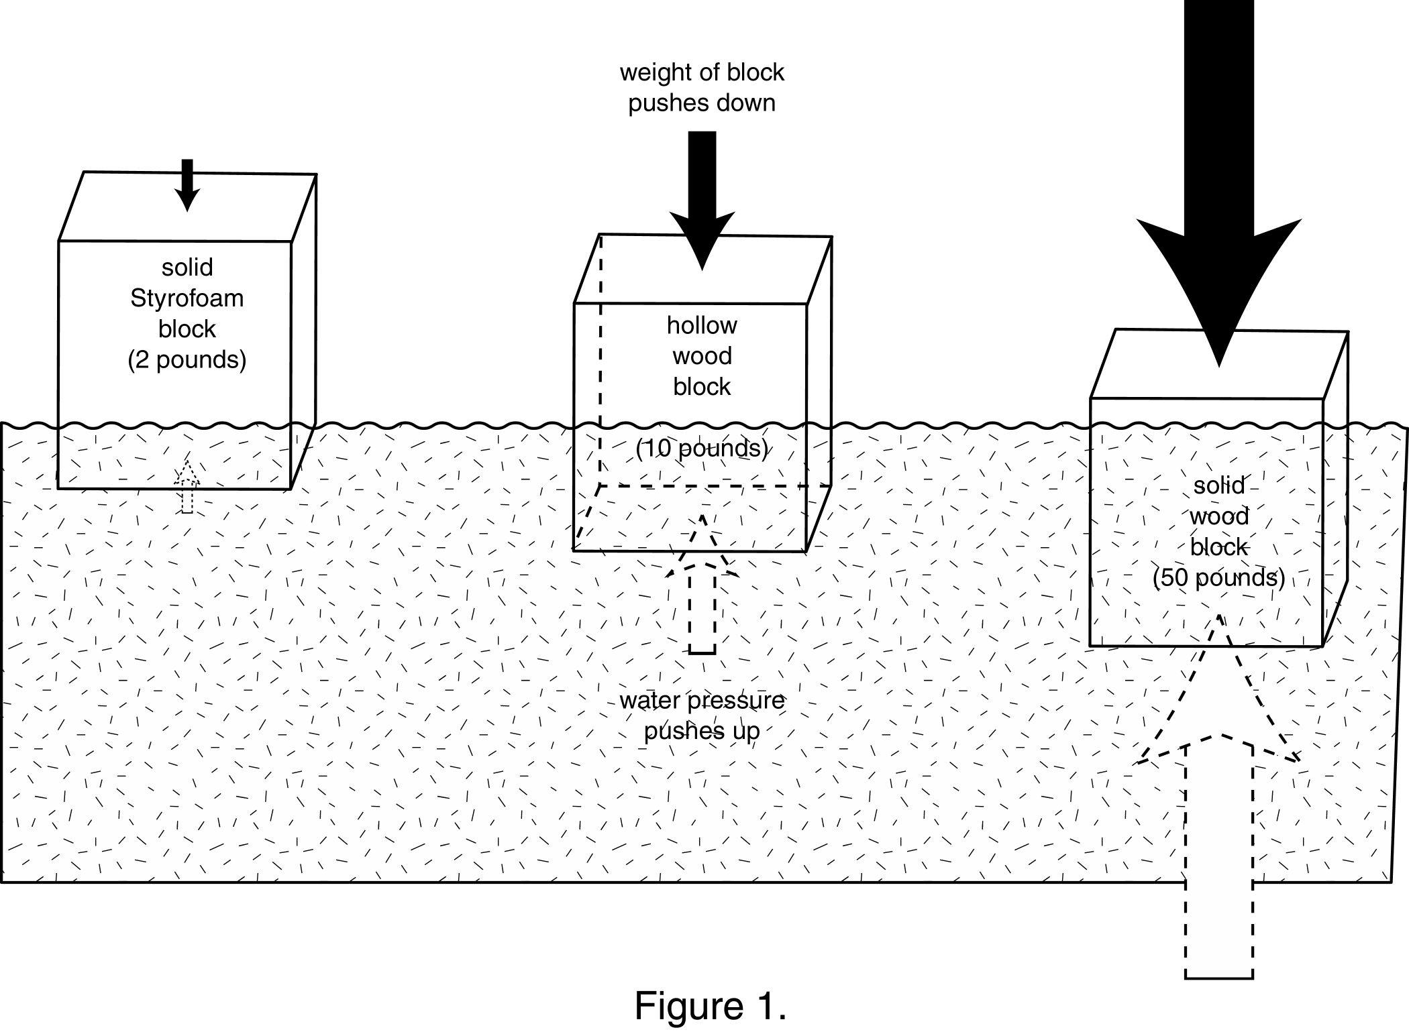

The foam block is so light that only a small amount of water pressure is needed to balance the mass of the block and let it float. The water pressure is slight up at the surface of the water, but since very little pressure is needed, the foam block does not sink very deeply into the water. The hollow wooden block, however, has to ride lower in the water in order to encounter enough water pressure to keep it afloat. The solid wood block, meanwhile, rides quite low in the water compared to the other two blocks. It has to extend even more deeply into the water than the hollow block, down to where the water pressure is high enough to counteract its greater mass.

But why does modeling clay, which is denser than water, float when it is given a bowl-like or boat-like shape? Or how do ships, for which steel is the main structural component, manage to float? The reason is that their shapes provide a large area for the water pressure to act against. The total buoyant force on an object equals the water pressure at its floating depth times the area of the object in contact with the water. This means that the more area you can give a material, the higher it can ride on the water, where the water pressure is much less. If the solid cube of wood in Figure 1 were stretched out into a plank that was eight feet long, nine inches wide, and 2 inches high, it would have the same weight and volume as the cube, but it would float nicely right at the surface of the water. This is because the plank would have six square feet of area for the water pressure to push against instead of only one square foot the block has.

Extensions

Ask students if they themselves are floaters or sinkers. Ordinarily, humans float, but barely. Our bodies contain mostly water, but we do have minerals in our bones, which are denser than water, and air in our lungs (even when we exhale fully, there is still some residual air inside), which is much less dense than water. No matter how thin we are, we all still have some amount of fat in our bodies, which is less dense than water. How easily we float depends largely on how much body fat we have. We can also float better if we fill our lungs and hold our breath.

You can also ask your students if it is easier to float in a lake (fresh water) or in the ocean (salt water). They should remember, if they have had any experience, that it is easier to float in the latter. Ask them why this is true, and give them some time to try to work out this puzzle. You may need to remind them what density really means; it is the amount of stuff packed into a given space, and liquids and gases have densities, too. Ocean water has salt, a type of "stuff", dissolved into the water. With more stuff in it, ocean water is denser than fresh water. Put another way, a gallon of salt water weighs more than a gallon of fresh water. Because of this weight difference, when an object floats in salt water, a smaller volume of water needs to be displaced than would be needed if the water contained no salt. Because less salt water needs to be displaced, an object floats higher in the salt water. We humans find it easier to keep our heads out of the water when we float in salt water because we don't need to displace quite as much water as we would in fresh water.

Your students can design some simple experiments to compare the volumes of displaced liquid when clay boats float in fresh versus salt water. (Sea water contains about 3.5% salt, so students can make 500 mL of "artificial" sea water by combining 17.5 grams of table salt (or NaCl) with 482.5 mL of water.) You can also ask your students what would happen when a fully loaded cargo ship travels from the ocean up into a large river such as the Amazon. They can simulate this experience by making a clay boat and filling it with as many metal washers (from the Clay Boats exercise) as it will hold without sinking in salt water. Then they can carefully move the boat and its load into a container of fresh water, where it will most likely sink.

If students have ever swum in a deep lake in the summer, they may have discovered that the surface water was warm, but if they dove down a few feet, the water became cooler. The colder, denser water remains at the bottom, unless something physically causes the warm and cool water to mix. (In a relatively shallow swimming pool, the action of swimmers is enough to keep the water mixed.) Students can use their clay boats to try to compare the densities of very hot and very cold water. However, the density differences are so small that students will probably not be able to measure the slight differences in the displaced volumes accurately enough to notice any density differences. (There is only a 1.4% difference between the density of ice water at 4° C and hot tap water at 55° C.) That doesn't mean students shouldn't attempt the experiment! Their results would, in fact, lead them to conclude that no such density differences exist. They could then be asked to do some library research to find the densities of water at different temperatures, and once that was accomplished, ask them if their experimental set up would have allowed them to detect the reported differences. There is a useful lesson about the limitations of measuring methods here. You can ask your students what kinds of instruments would be needed in order to get the required accuracy.
You can also ask students to speculate about what would happen to an oil tanker that was loaded with crude oil from the very cold and very salty northern Atlantic Ocean, and then traveled to the tropical, fresh water Amazon River to deliver it. (The ship would sink lower in the water in the Amazon.) Students might be interested to know about the Plimsoll lines painted on the hulls of ships, which indicate how fully ships can be safely loaded under a variety of water and climate conditions. These are shown in the figure below.
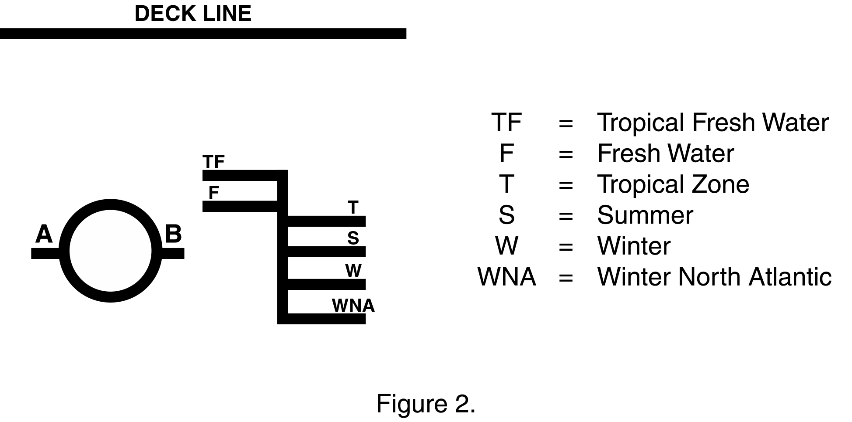
These markings came about over a hundred years ago, at a time when England was enjoying the fruits of the Industrial Revolution. Manufactured goods were being produced and exported as never before, and unfortunately, it was not uncommon for greedy ship owners to both overload and heavily insure their boats before launching them on their trade routes. As a result, a great many ships were lost; in one year alone 411 ships were wrecked along England's coast, and over 500 sailors drowned. Not surprisingly, sailors in the Merchant Navy grew reluctant to work on what they considered dangerous ships. Many were more willing to spend twelve weeks in prison for disobeying orders than they were to set sail on such vessels. At one time a prison inspector in southwest England found that nine out of twelve inmates were sailors who had been jailed for desertion.

Samuel Plimsoll, a Member of Parliament, became concerned about what he called the "coffin ships" of the times, and fought for several years for safety regulations. After several defeats of his proposals, Parliament finally passed the Merchant Shipping Act of 1876, which made load lines painted on the sides of ships mandatory. The overloading of ships was not as common in the U.S., and it wasn't until 1929 that Congress passed the Load Line Act here. Since then, the practice of applying load markings has become worldwide.

The basic load line symbol consists of a circle with a horizontal line passing through the center. The letters on either side of the circle indicate the organization that certified the load level. In the example above, the A and B stand for the American Bureau of Shipping. The placement of the line depends on a lot of factors, including various aspects of the hull shape, the length of the boat, and the type of cargo. The additional lines to the right of the circular symbol show the limits for different water types and climates, reflecting the density differences present at the time of loading.

What Floats Your Boat?

Instructions for Students
Introduction

In the density experiments you just completed, when you put an object such as a lump of clay into a full beaker of water, water spilled over the top. That was because in order for the clay to enter the water, it had to push some of the water out of the way, or displace it. The only place the displaced water could go was up and over the top of the beaker. The amount of displaced water equaled the volume of the lump of clay.

In the Clay Boats exercise, you took a lump of clay and shaped it so that it floated on top of the water. Now you will take a look at the relationship between floating objects and displaced water.

Procedure

1. Find and record the mass of your lump of clay.
2. Find and record the volume of your lump of clay.
3. Fill a 500 mL beaker about three-quarters full of water. On the outside of the beaker, make a mark to show the water level.
4. Without splashing any water, lower your lump of clay into the beaker. Make a new mark to show the new water level.
5. Without overflowing the water in the beaker, remove the clay and pat it dry with a paper towel. Shape the clay into a boat shape that you think will float inside the beaker. Before putting the clay in the water, predict where the new water level will be by drawing a short, dashed line on the beaker.
6. Carefully place the clay boat on the water surface. Mark the new water level. What happened? How close was your predicted water level to the actual water level?
7. Find and record the volume of the water displaced by the clay boat.
8. Find and record the mass of the water displaced by the clay boat.
9. Compare the volumes and masses of the displaced water to the volumes and masses you determined in steps 1 and 2.
10. Squash your clay boat back into a lump, and remove about one-quarter of the clay. Set it aside. Using the remaining clay (the larger portion), repeat steps 1 - 9, above.

When you repeated the steps with a smaller lump of clay, did you get similar results?

Sample Activity 4: Paper Towers

Synopsis

Each student makes a tower using two sheets of newsprint and ten inches of transparent tape. The object is to build the tallest tower that will resist being blown over by the teacher from one arm's length away. In the process, students formulate the basic engineering principles of tower design.

Objectives

This exercise provides students with an opportunity to use model-building as a way to help understand the forces and phenomena at work in the world around them. This process skill is a component of the Science as Inquiry strand of the NC Standard Course of Study for Middle School Science: "Mastery of integrated process skills: formulating models." Likewise, this exercise meets the NSES Content Standard A (Science as Inquiry) for levels 5-8, "Abilities Necessary to do Scientific Inquiry: develop descriptions, explanations, predictions, and models using evidence."

Through follow-up discussions, specific curricular objectives can be addressed. Depending on the direction of these discussions, students can be expected to be able to do any of the following:

- describe gravity as a universal force that pulls everything toward the center of the earth;
- describe the role of center of mass in the movement of an object;
- analyze the relationships between form and function in both living organisms and man-made structures; and
- describe science and technology as human endeavors, influenced by the prevailing cultures and beliefs of the time.

Introduction

This exercise gets students right into using their hands and having to think and plan. They experience success right away and they get immediate appreciation for their peers’ ideas. They will not be intimidated by numbers or equations, yet they should come away with a tangible sense of what is meant by concepts such as center of gravity (center of mass) and wind resistance. When the exercise is over, they get the additional message that much of engineering is common sense. We have taken two class days, as shown here, but one could eliminate the second tower, do the discussion at the end of the first day, and move on. Adding information about the Washington Monument and the Eiffel Tower after they have made their own towers allows them to feel the structures rising out of the history and sociology of real towers.

Procedure

Materials:

- Newsprint the size of a full size newspaper. A hundred sheets for 20 students will be enough for two days with some extra pieces in case of mishaps. This can be purchased from a school supply or paper supply store. You might even get a gift from a local newspaper. (Two caveats: Newsprint that comes on pads is often smaller than a full sheet of newspaper and more expensive. That's okay, but the towers will be smaller. Newsprint from actual old newspapers works just fine, but it will already have some creases in it. Again, not a serious problem; just something to consider.)
- Handy rolls of scotch tape, any width.
- Scissors.

Assignment for Day 1: Each student should take 2 sheets of newsprint and 10" of Scotch tape and build a paper tower as tall as she can that will resist being blown over by the teacher from one arm’s length away. Do this in 30 minutes or so. We do it on the floor. Paper can be cut, torn or folded to taste. Tape can only be used to attach paper to paper. Tape should not be used to attach paper to other objects or the floor.

When setting up this exercise, we think it is important to keep the directions short and sweet. Do not belabor these rules. Do not talk about the principles of tower design. That discussion will come after the students have had a chance to discover some of those principles for themselves.

The extent to which you bend these rules is entirely up to you. Ten inches of tape should be about enough to do the job. But some students will need a bit more. The main issue here is that the tape is just used to connect paper to paper and does not become a major structural material. We tell the students they will have 30 minutes, but we often extend this time. Just make sure to leave enough time to test each tower.

The Test: Students watch and note what happens when the teacher decides on direction and gives one big breath blow to each tower. It is important that all students watch each test. This is an important step in their learning from each other. Do not discuss what happens; just continue until all towers have been tested. Measure the height of the tallest tower that did not fall. Record this number.

The Science Notebook: After all the towers have been tested, ask the students to write about their experiences. We prefer having each student keep a science notebook. At this stage in the exercise, they might write about some or all of the following:

- Describe what they did to build their tower, including any difficulties they had in getting it to stand up. This description should be clear enough that another person could read it and reproduce a reasonable copy of their tower.
- Describe what happened when their tower was tested. Did it sway and then right itself? If it fell over, exactly what did they see? Did the whole tower fall as one piece? Or did it buckle in the middle?
- Finally, have them answer this question: “What instructions would you give a friend so that he or she could do this exercise successfully? In other words, give the simplest rules of tower design.”
- Note that it is entirely proper for students to write about what they saw when other students’ towers were tested. Or even to write about good techniques they saw, even if they had not thought of them on their own.

Discussion: After the students have finished writing in their notebooks, begin the class discussion asking this question again: “What instructions would you give a friend so that he or she could do this exercise successfully? In other words, give the simplest rules of tower design.” As students offer statements, write their responses on the board. Try to capture those responses in the students’ own words. They will probably generate a list something like this (though they will almost certainly not use words like tensile and center of gravity):

- The center of gravity must stay over the base.
- Make the tower stiff enough to achieve this.
- Keep the weight low.
- Make the base wide.
- Minimize the surface area and thus the wind resistance.
- Use a tubular triangular support at the base. This is the most rigid structure for the weight.
- Use tape and/or paper as tensile materials to attach the legs to the base. (These might be struts between tripod legs and the base of the tower that will keep the legs from splaying out.)

When the list above, or at least the first 4 or 5 rules, stated in the students’ own words, are written for all to see, draw a line over them and above that write in block letters: ENGINEERING PRINCIPLES OF TOWER DESIGN. This is the evidence that engineering is common sense. These principles are applied by every engineer in designing every tower that is ever built to last. Students make these statements from their knowledge and experience in life, which defines common sense.

This class-generated list could be added to the students’ notebooks.

We have seen classes in which all the students tried to build tall towers, but very few considered the nature of the base. And we have seen classes in which none of the students paid any attention to wind resistance. The result in each case might be that the students didn't really have much to learn from each other. The discussion, then, might reveal some of the important concepts. However, do not just give away the tricks of the trade. Try to guide the discussion so that students articulate the basic concepts in their own words. Once armed with some information generated by their peers, the students are ready to hear the assignment for Day 2.

Assignment for Day 2: Give this assignment at the close of Day 1. Suggest that students practice making towers at home. They may try as many techniques as they like, as many times as they like. Tell them that in the next class they will be given fresh materials, and they will get to build another tower. As a homework assignment, ask students to write a paragraph about what they will try to do to build a better tower on Day 2. This could include a diagram.

On Day 2, you might be more rigid about the time limit, since the exploration stage should have been accomplished at home. Test the new towers and measure the tallest. Compare these results with the Day 1 results. Typically, the Day 2 best is twice as tall as the Day 1 best. One year, one of our students made a tower that touched an eleven-foot ceiling! We have also observed that many more students build successful towers on the second day.

Day 2 discussion: Here are some suggestions for questions and some possible answers.

- “What design aspects made so many Day 2 towers so much taller than Day 1 towers?”
(Craftsmanship and care with folding and rolling!)
- What is craftsmanship? How does one do it well? How can one tell by looking at something the level of excellence of the craftsmanship?
- “How many ways can a tower fail?”
(They can fall over or bend over or buckle.)
- “What about one that leans or bends a bit but does not fall? Is that failure?”
(It is for a building because humans like horizontal floors. But pine trees get along quite nicely when they bend a bit.)
- “What does this say about a major difference between nature’s engineering and human engineering?”
(Plants and animals can survive a great deal of posture-damaging wounds by means of healing and regeneration, which humans have yet to engineer.)
(Humans must have horizontal floors to walk on, so walls must stay vertical.)

Extensions

The sociology of tower design. The following information is from:

David P. Billington, 1978. Structures and the Urban Environment. Lecture Notes 1980 CE 262. Princeton University Dept. of Civil Engineering.

Washington Monument

1783 Congress ordered equestrian statue of George Washington.
1799 Congress ordered marble monument to George Washington.
1801 $200,000 appropriated by the House, but Senate did nothing.
1833 Private citizens organized Washington National Monument Society and started raising funds.
1836 $28,000 raised. Invited designs to cost less than $1,000,000. Won by Robert Mills for a 500' tall obelisk resting on a 100' tall by 250' radius Greek temple.
1848 Congress & President Polk broke ground.
1854 No temple. Shaft was 152' up for $230,000. Anti-foreign, anti-Catholic group, the American Party, was angered because the Society had accepted a block of marble from the Pope. They destroyed the marble block, occupied the offices of the Society, seized its records, and voted their own members as officers, thereby outraging Congress, which stopped the flow of money and halted construction. Eventually, the American Party collapsed. Still no more money from Congress. The tower stood 21 years unattended.
1876 Centennial year. Congress appropriated $200,000 and ordered the Corps of Engineers to complete construction. The tower was leaning, so foundation work lasted till 1880.
1884 December 6, the final 3300 pound capstone was set in place.

The Washington Monument is still the tallest masonry tower ever built. Since stones cannot carry tension between them, wind resistance is entirely due to dead weight in compression alone. It tapers: the base is 55' square with 15' thick walls; the top is 34' square with 18" thick walls. The Monument is 1000 sq ft at top. Thirty people can go up per elevator. There are 33 sq ft of window for a super view of Washington, DC. No facilities for anything else.

The Monument is the dominant element in the DC landscape. It is a great central sign as an immense structure in a broad park. It is decoration to be admired from afar. Scientifically, it is an efficient masonry column. Socially it is a closed trip to a fine view. Symbolically, it is an elegant example of pure form that orients every sightseer from a distant perspective.

Eiffel Tower

1886 Competition for a tower as the center for a world's fair exposition. Other designs submitted included a huge tower-pump that would humidify Paris in the dry season, a 300 m tall guillotine to evoke the revolution, and a cylinder of lights that would allow every Parisian to read his newspaper at midnight anywhere in the city.
1887 Eiffel signed a pact with the city of Paris: He must complete the tower in less than 2 years for 1.5M francs, and he could charge admission (and keep it all) for 20 years when it would revert to Paris.
1887 Broke ground January 28. By June 30, the foundation was done and the tower started. First platform at 60 m by April 1. Second platform at 75 m by July 5. In the fall, there was worry that 228m was the theoretical maximum height of an iron structure (theory by a professor of mathematics in the Academie Francaise).
1889 Tower completed 1 month ahead of schedule on March 30.

The tower is entirely of iron: Eiffel did not trust steel! It is extremely light for its height, so the vertical load is light (150 lbs/sq in), but the wind load is high due to its great surface area. Therefore, it has a parabolic shape instead of a straight taper. Stresses in wind are nearly constant top to bottom.

The tower’s openness allows visitors to see out all the way up. It has three platforms with restaurants, shops, and toilets. It accommodates 10,000 people at once.

It is scientifically an efficient metal cantilever, socially a popular and open trip to a great view, and symbolically an elegant example of pure form, engaging sightseers both from a distance and from a close-up, intimate view of its structure.
Both towers have meanings that go to the hearts of the cultures in which they arise. The monument, closed and classical, reminds one of other times and places and permits much less of an expanding personal vision than does the open, original structure of the tower.

 | Washington Monument | Eiffel Tower
Height | 170 meters  555 feet  (56% of Tower) | 300 meters  984 feet
Weight | 81,000 tons | 9,700 tons  (12% of Monument)
Weight/Height ratio | 1,600/1 | 9/1
Number of visitors at one time | 30 | 10,000
Cost | $1,300,000  ($300,000 from government) | $1,560,000  ($1,100,000 recovered in first 6 months. Now self-supporting.)
Time from idea to completion | more than 100 years | less than 5 years
Deflection | 0.02% of height | 0.04% of height
Eco-vulnerability | little | rust—needs paint often
Cost of renovations | $9,000,000 (1999-2000) | $30,000,000 (1980s)

INSTRUCTIONS FOR STUDENTS

At the beginning of class, you will be given two sheets of newsprint, the paper that newspapers are printed on. You will also get 10 inches of tape. Your goal is to build the tallest structure you can that the teacher cannot blow over with one strong breath from one arm’s length away.

You may fold, cut or tear your paper and tape it as you wish. You may only use the tape to attach paper to paper. You may not use the tape to attach your structure to the floor or to any other material in the room.

After 20 minutes, construction will cease and the teacher will begin the blowing tests.

Sample Activity 5: Tower investigation and the egg

SYNOPSIS:
Towers have been a part of developed society for centuries. Towers serve a variety of purposes, as a lookout to a cellular tower. In this activity student groups will build three types of towers, engineering them to hold an egg one foot high for 15 seconds.

STANDARDS:
II. Engineering Design
2.1 Identify and explain the steps of the engineering design process, i.e., identify the need or problem, research the problem, develop possible solutions, select the best possible solution(s), construct a prototype, test and evaluate, communicate the solution(s), and redesign.
2.2 Demonstrate methods of representing solutions to a design problem, e.g., sketches, orthographic projections, multiview drawings.
2.4 Identify appropriate materials, tools, and machines needed to construct a prototype of a given engineering design.
2.5 Explain how such design features as size, shape, weight, function and cost limitations (i.e., ergonomics) would affect the construction of a given prototype.
V. Construction Technologies
5.1 Describe and explain parts of a structure, e.g. foundation, flooring, decking, wall, roofing systems.
5.3 Explain how the forces of tension, compression, torsion, bending and shear affect the performance of bridges.

WHAT WILL THE STUDENTS LEARN?
- Engineering Design Process (egg holder at top of tower)
- Parts of a structure
- Types of towers and comparisons
- Safe usage of tools and machines
- Forces that must be taken into consideration when building structures

BACKGROUND INFORMATION:
The ENGINEERING DESIGN PROCESS has the following steps: identify the need or problem, research the problem, develop possible solutions, select the best possible solution(s), construct a prototype, test and evaluate, communicate the solution(s), and redesign.
TOWERS are usually classified into three categories: guyed or cable supported, free-standing or self-standing, and monopole. The self support and monopole towers are both similar in that neither require guy wires or any other support structure. Also, most engineers choose the guyed type because it is the most inexpensive route.
As a general rule there are three main specifications needed to choose a tower site: site selection, tower type, and tower specification knowledge (or tower code) within the community.

MATERIALS:
- Pictures or examples of towers
- Internet locations of tower information (see links under REFERENCES)
- Cardboard tubes and sheet material. Cardboard sheets can be purchased from local paper suppliers or donated from local printers. An allotted amount should be provided to each team of students for each tower problem.
- Materials readily available in the classroom such as straws, tape, hot glue, string, etc.
- Note: Where available, sturdier towers can be built with small wooden dowels and plastic tubing. This would enable students to be exposed to a variety of hand and power tools

PREPARATION:
Find materials, websites. Provide photocopies of tower diagrams if desired.

DIRECTIONS:
      - Introduce the topic of towers, perhaps facilitate a discussion on different types of towers and there uses. Talk about the design process, including a discussion on the benefits of sketches, multiview drawings, and orthographic projections.
- Organize students into small groups.
- Explain criteria for the tower design and construction. Each group will design and make one of each of the following: a guyed tower (cable supported), a self-standing tower, and a monopole tower. Each tower must be able to support the weight of an egg for 15 seconds
- Students will test and measure the three types of towers by evaluating height, strength (ability to hold an egg), and the amount of material usage
- Students will participate in the presentation of the group solutions to the class.
- Students will present comparisons or advantages and disadvantages of the different types of towers

INVESTIGATING QUESTIONS:
- What is the purpose of towers? Why is one type of tower preferable to another?
- How can an egg be held and supported at the top of a tower?
- How can we build models to represent the three recognized types of towers?
- What is meant by tension, compression, torsion and shear in construction?
- What are the parts of this structure (tower) that are similar to those found in bridge design?

REFERENCES:
Sturdivant, Peter. So You Want to Build a Tower?
http://www.angelfire.com/me/blkstrpra/aug98.html. August 9, 2001. [online].
Tower Photographs. http://www.pre-engineering.com/resources/towers.htm
August 9, 2001. [online]. (Used with the permission of Pre-Engineering Software Corporation.)

Directions: Tower Investigation and the Egg
Read documents on tower types. You will find them online or your teacher will provide them.
You are required to build 3 towers to hold an egg a foot high for 15 seconds. You will have to build a guyed tower(cable supported), a self-standing tower, and a monopole tower. Your teacher will have a selection of materials from which to choose. Be sure to draw designs of your tower on paper, labeling the type and the chosen materials, and writing why it is designed the way it is. Be sure to consider the forces to which the tower will be subjected.
Build the towers and test them by putting an egg on them for 15 seconds.
You will be asked to present to the class the strengths and weaknesses of each type of tower, based on your experiments and the articles you have read.

Sample Activity 6: File Card Bridges

How many pennies will your bridge hold?


What do I need?
- 4 to 6 books (enough to make 2 stacks the same height)
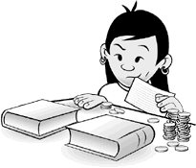
- A package of file cards
- 300 to 400 pennies (loose or in rolls)
- Scissors
What do I do?
- Make 2 stacks of books with a gap of about 4 inches between them. Make sure the stacks are the same height.

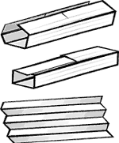
- Lay one file card over the gap between the books. About 1/2 inch of the card should be resting on a book at each end. How many pennies do you think you can pile on this flat bridge before it falls into the gap-5? 10? 100? Try it and see how close your guess was.

- Without adding anything to the file card, try to make your bridge stronger. How could you change a file card to make it stiffer? What happens if you fold the card in half? If you make an arch? How about if you fold the card into pleats?

- Make a bridge, then test it to see how many pennies it will hold. Some of your bridges may hold a few pennies before falling down. Others may be stronger, but the pennies may slide right off. And some bridges will probably hold a lot more pennies than you'd think.
What’s Going On?
How many pennies can my file-card bridge hold?
You may find that a file-card bridge can hold more pennies than you'd think! Here are the results of the file-card bridges that the Science-at-Home Team built.
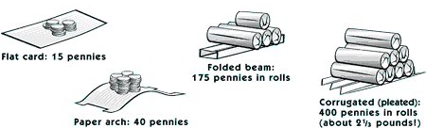
A roll of 50 pennies weighs 132 grams-that's a little more than 41/2 ounces.
How many kinds of bridges are there?
You might think that bridges come in an infinite variety of forms. But if you get right down to the structural elements of a bridge, there are really only three kinds: beam spans, arch spans, and suspension spans.
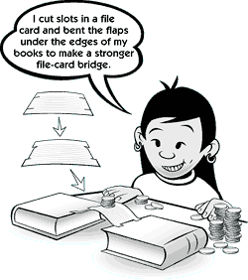
The simplest kind of bridge is a beam bridge. A log that has fallen across a river makes a beam bridge. So does a board laid across a puddle, or a span of steel laid across a body of water, or a file card laid across two books. A beam bridge relies on the stiffness of the building material. If the log across the river sags, it doesn't make a very good bridge.
Arches have been common features in buildings since 1,000 B.C., but they didn't appear in bridges for another thousand years. Roman roads, built at the height of the Roman Empire's power, were often supported by stone arches.
Suspension bridges, like the Golden Gate Bridge in San Francisco, rely on a cable or rope for their support. Each end of the cable or rope must be anchored to the bank-tied to a tree, a boulder, or (in modern suspension bridges) a massive block of concrete called an anchorage. The cable or rope pulls on the anchors, but as long as they don't move and the cable or rope doesn't snap, the bridge is stable.
What kinds of bridges can I make with my file cards?
Using just your file card, you can make two of the three different kinds of bridges. When you lay a file card across two books-even if you've folded the card into pleats first-you've made a simple beam bridge. If you cut slots into the card, tuck the flaps under the edges of the book covers, and push the books slightly together, you'll make an arch bridge. We haven't figured out how to make a suspension bridge out of a file card, though. If you come up with a way to do it, please let us know!
Wow! I didn’t know that!
As an advertising stunt for a paper company, Lev Zetlin Associates designed a full-sized paper bridge that was strong enough to support a car!

This activity was taken from: http://www.exploratorium.edu/science_explorer/card_bridge.html

